
Your mental health first aid kit

Write down ideas of things you can do to help you feel better if you’re having a tougher time. If you need some inspiration, or you’re finding
it difficult to fill out, it might help to chat to a mate, an adult you trust,
or a Childline counsellor. You can also get advice from our website: childline.org.uk/mental-health-first-aid-kit/

Ways I can relax:

Things I can distract myself with:

Things that have made me feel good in the past:

I can chat to:
Name | How they can help me | When they’re available
Tips to help you build your kit
- Fill in your kit when you’re feeling calm
- Keep it simple and make it easy to understand
- Remember - you don’t need to fill it all in now
- Ask for help from someone you trust, like a mate, an adult in your life,
or a Childline counsellor
- Add things that have worked before, or new ideas you want to try
- Keep updating your kit if you find something new that works for you

You could include…

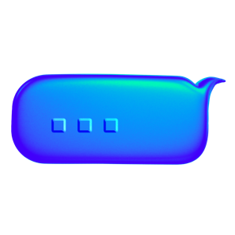
People you can talk to:
- Your mate
- Your parents, carers or a teacher
- Your CAMHS worker, or a crisis team
Ways to feel good
- Have a bath or shower
- Do something you want to get done
- Watch something funny on something like YouTube or TikTok
- Get stuck into something creative
Relaxation
- Take a deep breath in while counting “1, 2, 3, 4”, then breathe out while counting “1, 2, 3, 4”
- Focus on what’s around you, name 5 things you can see, 4 things you can touch or feel, 3 things you can hear, 2 things you can smell and 1 thing you can taste
- Lie down and close your eyes for 5 minutes
- Listen to your chill out playlist, or make one if you don’t have one yet
Distractions
- Play with a fidget toy
- Tidy or organise your room
- Shift your attention with a simple exercise. For example, name one animal that begins with each letter of the alphabet (e.g. A for Aardvark)
- Listen to a podcast or watch a TV show you love

