**Your Mental health first aid kit**

Write down ideas of things you can do to help you feel better if you’re having a tougher time. If you need some inspiration, or you’re finding  
it difficult to fill out, it might help to chat to a mate, an adult you trust,   
or a Childline counsellor. You can also get advice from our website: [**childline.org.uk/mental-health-first-aid-kit/**](https://www.childline.org.uk/mental-health-first-aid-kit/)

**Ways I can relax:**

|  |
| --- |
|  |
|  |
|  |
|  |

**Things I can distract myself with:**

|  |
| --- |
|  |
|  |
|  |
|  |

**Things that have made me feel good in the past:**

|  |
| --- |
|  |
|  |
|  |
|  |

**I can chat to:**

|  |  |  |
| --- | --- | --- |
| **Name** | **How they can help me** | **When they’re available** |
|  |  |  |
|  |  |  |
|  |  |  |

**Tips to help you build your kit**

* Fill in your kit when you’re feeling calm
* Keep it simple and make it easy to understand
* Remember - you don’t need to fill it all in now
* Ask for help from someone you trust, like a mate, an adult in your life,   
  or a Childline counsellor
* Add things that have worked before, or new ideas you want to try
* Keep updating your kit if you find something new that works for you



**You could include…**

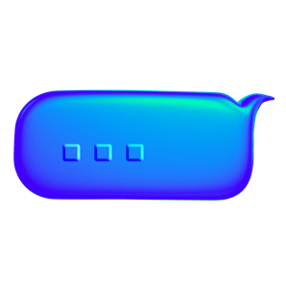

**People you can talk to:**

* Your mate
* Your parents, carers or a teacher
* Your CAMHS worker, or a crisis team

**Ways to feel good**

* Have a bath or shower
* Do something you want to get done
* Watch something funny on something like YouTube or TikTok
* Get stuck into something creative

**Relaxation**

* Take a deep breath in while counting “1, 2, 3, 4”, then breathe out while counting “1, 2, 3, 4”
* Focus on what’s around you, name 5 things you can see, 4 things you can touch or feel, 3 things you can hear, 2 things you can smell and 1 thing you can taste
* Lie down and close your eyes for 5 minutes
* Listen to your chill out playlist, or make one if you don’t have one yet

**Distractions**

* Play with a fidget toy
* Tidy or organise your room
* Shift your attention with a simple exercise. For example, name one animal that begins with each letter of the alphabet (e.g. A for Aardvark)
* Listen to a podcast or watch a TV show you love